Here's how firing a weapon might hurt your brain — literally
AUGUST 16, 20243:00 AM ET
By
Regina G. Barber
,
Jon Hamilton
,
Rachel Carlson
,
Rebecca Ramirez
LISTEN· 13:0313-Minute ListenPLAYLIST
- Download
- Embed
- Transcript
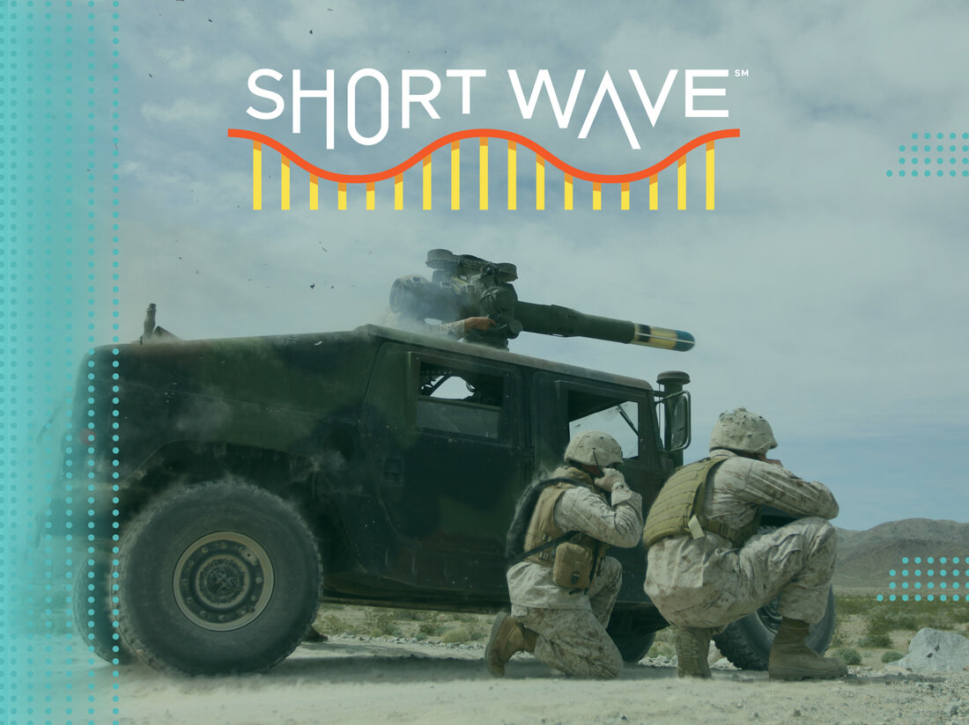
During the wars in Iraq and Afghanistan, many U.S. military personnel were exposed to blast waves from nearby explosions. Over time, the military realized that soldiers' brains had been injured by these blast waves — and that being exposed to many smaller blast waves could cause some of the same problems as getting hit by one big one.
Stocktrek Images/Getty Images
Some weapons used by the U.S. military are so powerful they can pose a threat to the people who fire them. When weapons are fired, an invisible blast wave travels through the brains of anyone nearby. Exposure to lots of these blasts over time – even low-level ones – has been shown to cause brain health problems for service members.
Think of it like football: Scientists still see signs of brain damage in players who don't typically get knocked unconscious but take regular, less severe blows to the head. In the military, scientists have measured something called overpressure, essentially the force of a blast. They've seen that it isn't just bombs causing overpressure — it's also the blasts from firing weapons.
These blasts can cause inflammation and damage blood vessels. In 2023, the Department of Defense created a fact sheet for service members that lists symptoms like headaches, memory problems and decreased hand-eye coordination. While the military has adopted a threshold for how much overpressure is considered safe — about four pounds per square inch, which is the level at which overpressure can burst an eardrum — nobody knows yet what that level means for the brain.
In the meantime, the military is working to reduce the risk for service members in training by doing cognitive testing to track brain changes and putting blast gauges on members who fire heavy weapons in training to better understand how much exposure occurs.
Questions or ideas you want us to consider for a future episode? Email us at shortwave@npr.org. We'd love to hear from you!
Listen to Short Wave on Spotify and Apple Podcasts.
Listen to every episode of Short Wave sponsor-free and support our work at NPR by signing up for Short Wave+ at plus.npr.org/shortwave.
This episode was produced by Rachel Carlson and edited by our showrunner, Rebecca Ramirez. Jon Hamilton checked the facts. The audio engineer was Kwesi Lee.
- Facebook
- Flipboard
- Email

